हरियाणा केन्द्रीय विश्वविद्यालय  जांट-पाली, महेंद्रगढ़, हरियाणा, भारत | 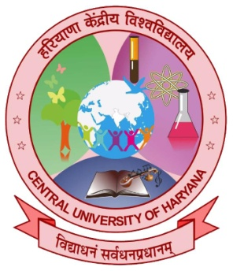 | CENTRAL UNIVERSITY OF HARYANA  Training & Placement Cell  Jant-Pali, Mahendergarh,Haryana, India

To
…………………………….
…………………………….
…………………………..

Sub: Request for Industrial training for six weeks/one semester
Dear Sir/Madam,

This is a matter of immense pleasure for me to share the Central University of Haryana, which was established as a dream project, has come up as an emerging centre for knowledge dissemination south Haryana. The University aspires to be one of India’s most dynamic and vibrant universities, responsive to the changing global trends and providing unparalleled educational opportunities for learning community. Some of the most important milestones achieved by the University are -Accreditation with A Grade by NAAC and securing Rank band 151-200 in NIRF rankings 2022.
With the objective of imparting quality education in the field of Engineering, the Central University of Haryana has launched the school of Engineering and Technology in the year 2016-17. The Department of Civil Engineering in the Central University of Haryana is offering four years B.Tech. Program. As part of academic requirements and keeping in view the necessity of the current scenario, trends, and technologies, a project work/industrial training from a renowned industry is important for the students. The duration for training is six weeks/one semester.
In this context, the Training & Placement cell is forwarding the name of following students……………………………. herewith for industrial training in your esteemed Department .
We are looking forward for your support as you are one of the leading Company worldwide. Kindly accord your permission with an intimation to us at your earliest convenience. Please feel free to revert for any further information.
Looking forward for a long and mutually fruitful association.

Dr Vikas Garg
Director, Training & Placement Cell,
Central University of Haryana,
Mahendergarh

